Geophysical Survey
Using Schlumberger for Groundwater Investigation
Investigation of groundwater using Vertical Electrical Sounding (VES) method for the determination of aquifereous zone in subsurface material to the depth of interest.
Location of Investigation
The area under investigation in Figure 1 is latitude 4.42898 and longitude 6.330615 located in Nembe Creek, Nembe LGA, Bayelsa State, Nigeria.
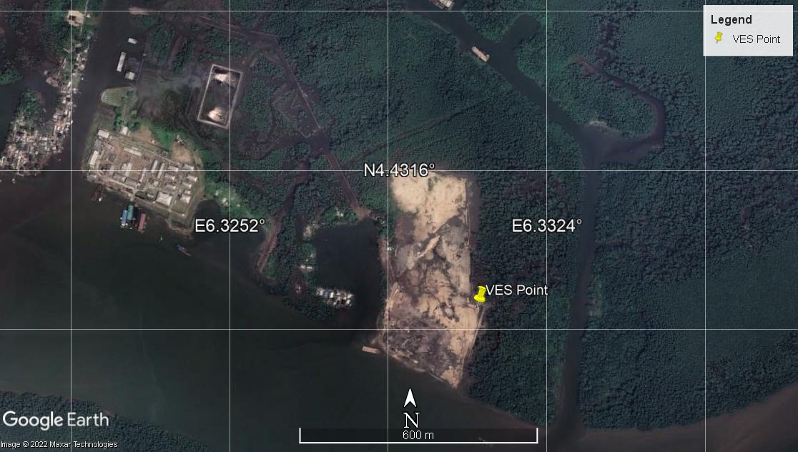
Figure 1. Location showing Vertical Electrical Sounding (VES)
Result and Interpretation
Figure 2 shows that VES results range from 0 to 100 m depth, with H, K and A curves indicating the presence of iron in the terrain, which is made up of top soil, clay, sandy clay Sand and Medium Sand strata. Based on the VES data obtained from Resistivity, we have the following notable layers, 0 – 0.6 m (Topsoil) 4.23 Ωm, 0.6 – 1.25 m (Clay) 8.09 Ωm, 1.25 – 2.59 m (Clay) 0.55 Ωm, 2.59 – 5.37 m (Clay)5.10 Ωm, 5.37 – 11.16 m (Sandy clay) 240 Ωm, 11.16 – 48.18 m (Sand) 5083 Ωm and 48.18 – 100 m (Medium sand) 935.7 Ωm. From the resistivity in Table 1 and Figure 3, the potential aquifer thickness is identified as 41.1 m.
The resistivity, thickness and depth of each profile are summarized in Table 1.

Table 1: Resistivity, thickness and depth of VES
S/N | Pa(Ωm) | Thickness(m) | Depth (m) | Lithology
1 | 4.23 | 0.6 | 0.6 | Top Soil
2 | 8.09 | 0.65 | 1.246 | Clay
3 | 0.55 | 1.342 | 2.59 | Clay
4 | 5.10 | 2.787 | 5.37 | Clay
5 | 240.00 | 5.788 | 11.16 | Sandy clay
6 | 5083.00 | 37.02 | 48.18 | Sand
7 | 935.70 | 51.85 | 100.00 | Medium Sand

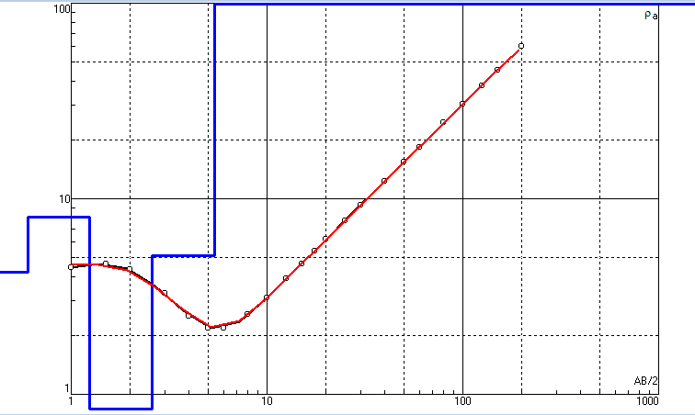

Figure 2: App. Res (Ωm) vs AB/2 (m)

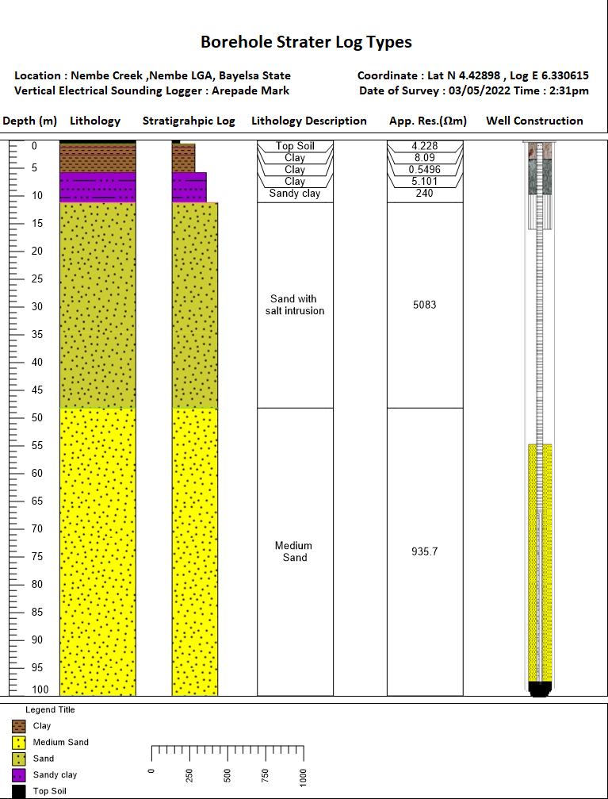
Figure 3: Show Borehole Starter Log Types Base on VES Results.

CONCLUSION
The lithology section of 70 – 93 m is the best recommended aquifer in the drilled section to position the screen, and the driller should be knowledgeable about the terrain in other to minizine iron content.

Arepade Mark
Geologist/Geophysicist

